### **EVALUATION OF BIG DATA PROCESSING, ANALYTICS AND CLOUD PLATFORMS**

Processing Big Data 7CS516 Assessment

Student ID: 100757077

University of Derby

College of Science and Engineering

### **Table of Contents**

**Introduction...............................................................................................................................3**

**Cloud Investigation...................................................................................................................3**

Evaluation Criteria**......................................................................................................................3**

Investigation Methodology**.........................................................................................................4**

Mapping to Evaluation Criteria**..................................................................................................7**

Comparison of AWS Redshift vs. Databricks**............................................................................8**

Summary**.....................................................................................................................................9**

**Big Data Procession and Analytics..........................................................................................10**

Data Preproccesing**.....................................................................................................................10**

Data Analysis**..............................................................................................................................13**

Machine Learning Implementation**.............................................................................................16**

Summary**.....................................................................................................................................18**

**Conclusion.................................................................................................................................19**

Summary**.....................................................................................................................................19**

Recommendation**........................................................................................................................19**

Future Work**................................................................................................................................19**

**References..................................................................................................................................20**

### **Introduction**

In the rapidly evolving field of big data, cloud platforms are becoming more and more popular for storing, processing, and analyzing large datasets. This report focuses on Amazon Web Services and Microsoft Azure, two leading platforms chosen for their scalability, infrastructure, and support for big data frameworks and machine learning workflows. Both platforms offer elastic resources, making them ideal for handling complex analytics tasks and fluctuating computational demands.

The importance of cloud platforms in big data is well-supported in the literature, with AWS and Azure recognized for providing scalable infrastructure and integrating advanced analytics tools (Hashem et al., 2015; Rittinghouse & Ransome, 2016).

In this report, I will also implement machine learning models on a selected dataset, including data preprocessing, feature engineering, and model evaluation, using both AWS and Azure to compare their performance in handling the ML workflow.

### **CLOUD INVESTIGATION**

### **Criteria for Evaluation**

The suitability of AWS and Azure for big data projects was evaluated using the following criteria:

**Performance at Scale**: Measures the platform’s ability to efficiently handle large-scale data workloads.

* **AWS**: S3 and Glue provided seamless integration and high-speed processing of large datasets.
* **Azure**: Blob Storage and Databricks enabled efficient data handling, with Databricks offering optimized clusters for faster processing.

**Elasticity**: Evaluates the platform's capability to adjust resources dynamically in response to workload requirements.

* **AWS**: Glue automatically scaled resources for ETL processes based on dataset size.
* **Azure**: Databricks scaled resources dynamically to accommodate both small and large datasets.

**Ease of Use**: Evaluates user experience, including tools, documentation, and setup simplicity.

* **AWS**: User-friendly interface enabled smooth S3 bucket creation, IAM role configuration, and Glue job setup.
* **Azure**: Databricks offered an intuitive workspace for data scientists, while Blob Storage provided easy integration with other Azure services.

**Cost Efficiency**: Analyzes pricing models, including pay-as-you-go costs and reserved instance pricing.

* **AWS**: S3’s pay-as-you-go storage model and Glue’s pricing based on job duration ensured cost optimization.
* **Azure**: Blob Storage offered a flexible pricing model, and Databricks used a consumption-based model to avoid over-provisioning.

**Security**: Examines data protection measures such as encryption, access control, and compliance with industry standards.

* **AWS**: IAM Roles provided fine-grained permissions for secure data access and integration.
* **Azure**: Built-in security features like RBAC and encryption ensured secure management of data in Blob Storage and Databricks.

### **Investigation Methodology**

The investigation follows a structured approach to evaluate AWS and Azure’s capabilities in handling big data workloads:

1. **Data Storage Setup**
   1. **AWS**: AWS S3 was chosen for its scalability and cost efficiency in storing both structured and unstructured data. A bucket was created to store datasets needed for preprocessing and analytics, including sales data, customer demographics, and territory information.

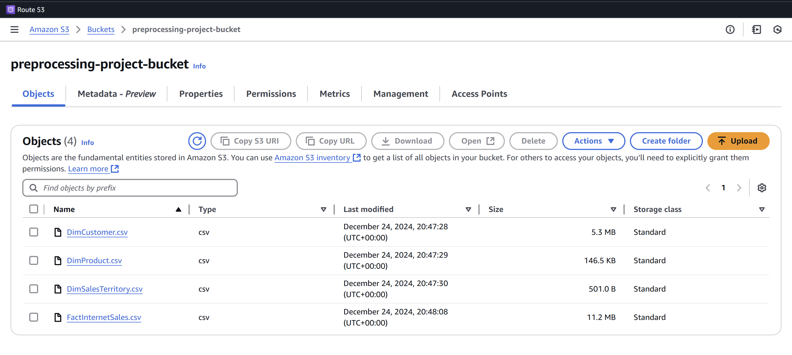 Figure 1: Amazon S3 Bucket: The datasets were uploaded in the S3 Bucket.

* 1. **Azure**: Azure Blob Storage was selected for storing large datasets, offering hierarchical namespace support and efficient methods for storing and accessing unstructured data.

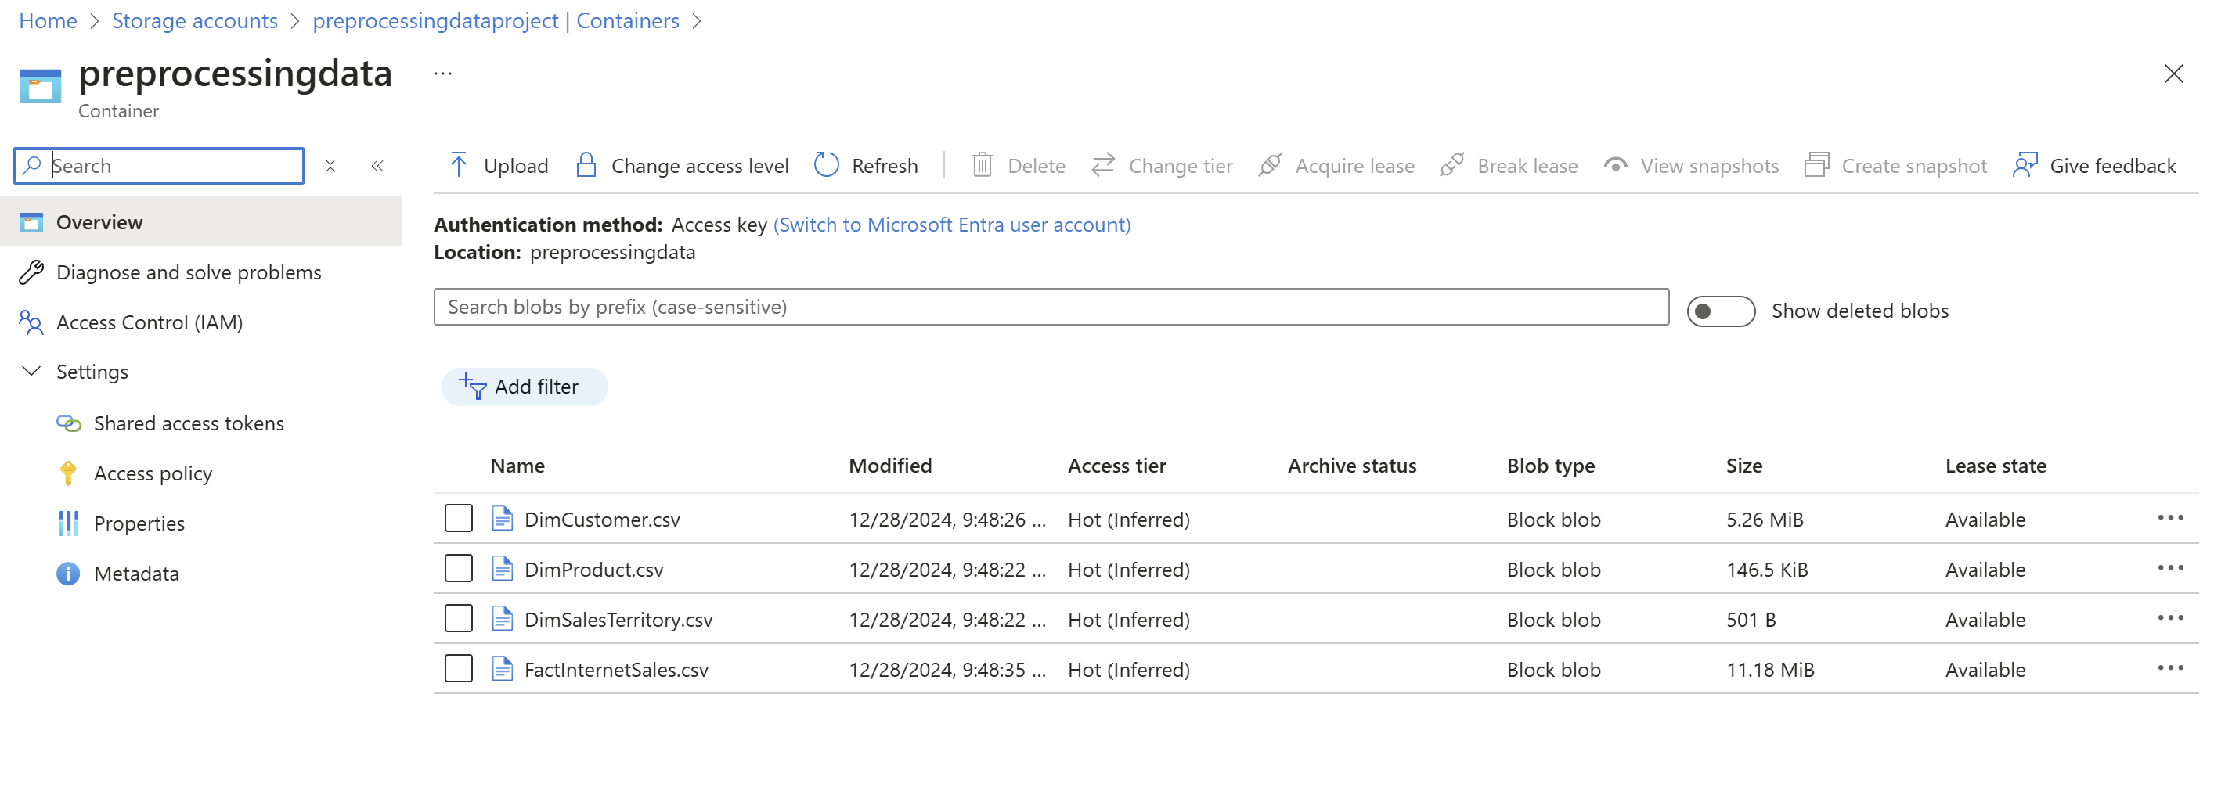Figure 2: Azure Storage: The datasets were uploaded in the Storage.

1. **Role Configuration**
   1. **AWS**: IAM Roles were configured to ensure secure access between services. The BigDataProjectRole was assigned permissions such as AmazonS3FullAccess and AmazonRedshiftFullAccess for seamless data integration.

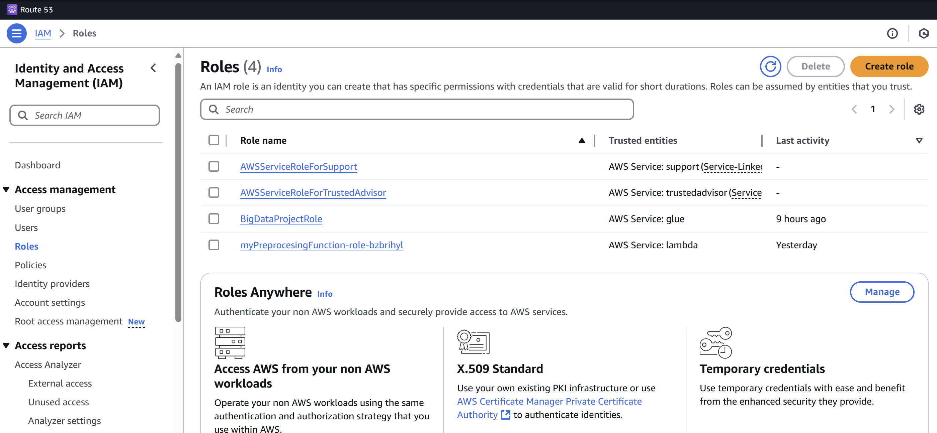 Figure 3: IAM Roles: The Roles I needed for this project.

* 1. **Azure**: Azure Active Directory (AD) roles were configured to enable secure access between Azure Databricks and Blob Storage. Permissions were granted to Databricks for reading and writing data from Blob Storage.

1. **Data Preprocessing**
   1. **AWS**: AWS Glue was used to automate ETL processes, including cleaning and transforming sales and customer datasets. Glue’s integration with other AWS services streamlined the workflow.

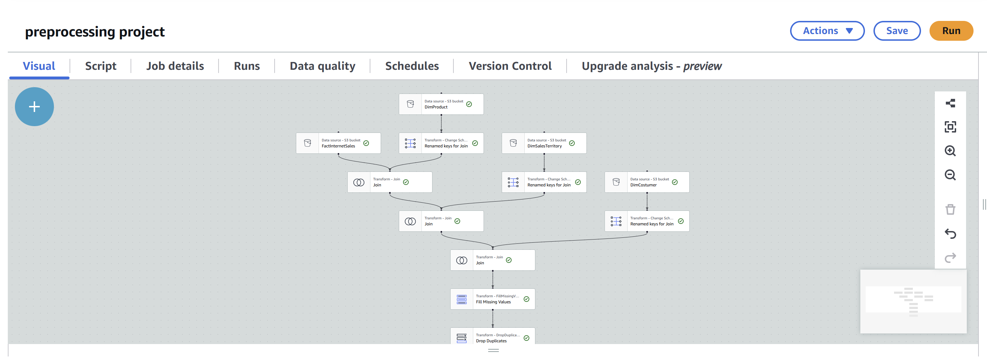 Figure 4: AWS Glue: Used for ETL.

* 1. **Azure**: Azure Databricks, leveraging Apache Spark, was employed for efficient data preprocessing. Databricks integrated well with other Azure services, providing a seamless data pipeline for transformation and analysis.

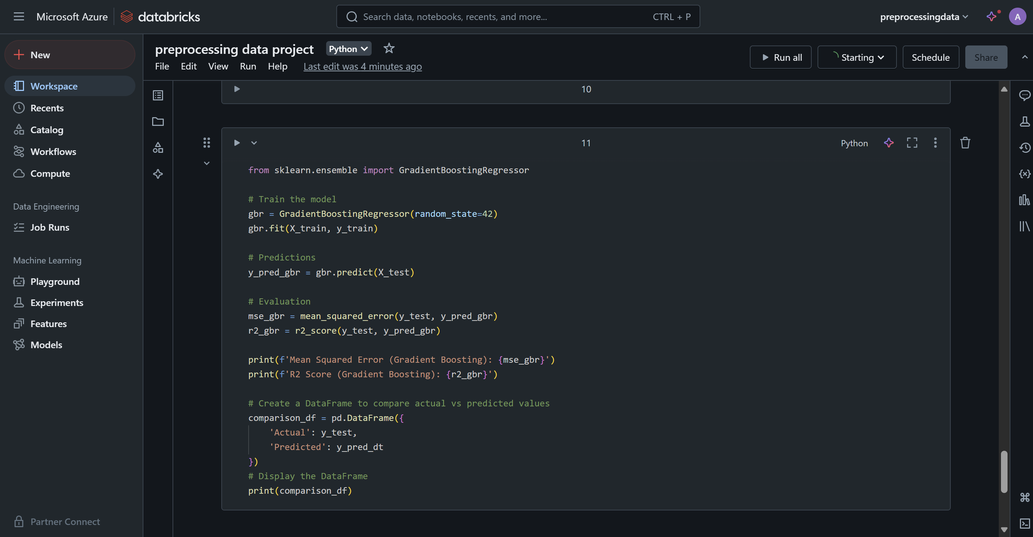Figure 5: Azure Databrick: The code for analysis and model implementations.

#### **4. Mapping to Evaluation Criteria:**

|  |  |  |
| --- | --- | --- |
| Feature | **Specific Mapping to Use Case (AWS)** | Specific Mapping to Use Case (Azure) |
| Performance at Scale | AWS S3 and Glue handled large datasets and processed millions of records quickly. | Azure Blob Storage and Databricks efficiently managed large datasets with optimized clusters. |
| Elasticity | A WS Glue scaled ETL processes based on data size, ensuring efficient job completion. | Azure Databricks automatically scaled resources during peak workloads. |
| Ease of Use | AWS provided an intuitive interface for S3, IAM roles, and Glue setup with clear documentation. | Azure Databricks had an easy-to-use interface and Blob Storage integrated well with Azure services. |
| Cost Efficiency | S3’s pay-as-you-go model and Glue’s ETL job pricing minimized costs. | Azure Blob Storage and Databricks offered flexible and cost-effective pricing models. |
| Security | IAM Roles ensured secure access and integration, protecting sensitive data. | Azure AD roles and encryption secured data and integration with Databricks and Blob Storage. |

Table of Evaluation Criteria

### **Comparison of AWS Redshift vs. Databricks**

**AWS Redshift:**

Amazon Redshift is a fully managed data warehouse optimized for complex analytical queries on structured and semi-structured data.

**Key Features:**

* **Columnar Storage**: Optimized for large-scale analytics, reducing I/O and accelerating query performance.
* **High-Speed Queries**: Utilizes materialized views, result caching, and columnar storage for quick query responses.
* **Integration with AWS Ecosystem**: Tight integration with AWS services such as S3, Glue, and SageMaker for seamless data pipelines and machine learning workflows.
* **Redshift Spectrum**: Allows querying data directly from S3 without loading it into Redshift, reducing storage and data movement overhead.
* **Focus**: Primarily designed for data warehousing and OLAP (Online Analytical Processing) use cases.

**Databricks:**

Databricks is a unified data and AI platform that focuses on large-scale data analytics, ETL, and machine learning workflows. Built on Apache Spark, it is highly flexible and supports multi-cloud deployment.

**Key Features:**

* **Apache Spark Backbone**: Enables high-performance distributed data processing.
* **Delta Lake**: Provides ACID transactions and scalable metadata handling, ensuring reliable data lakes.
* **Unified Platform**: Combines ETL, analytics, and machine learning in one environment.
* **Notebook Interface**: Interactive development environment for data engineering and ML with rich visualizations.
* **Focus**: Designed for advanced big data analytics, machine learning, and real-time data processing.

### **Summary:**

This report compares AWS and Azure in handling big data workloads, highlighting the strengths of each platform:

* **AWS** excels in performance at scale with highly scalable storage, automated ETL pipelines, and machine learning capabilities through services like S3, Glue, and Redshift. Its robust ecosystem makes it ideal for projects requiring seamless data storage, preprocessing, and modeling, with strong elasticity to handle fluctuating workloads.
* **Azure** stands out for its advanced analytics and big data processing capabilities with Azure Databricks. Databricks optimizes Apache Spark for data science and machine learning workflows, while Azure is ideal for hybrid cloud scenarios, offering seamless integration with on-premises infrastructure and robust governance and security features.

Both platforms are highly elastic, user-friendly, and cost-efficient, making them strong choices for big data projects. The selection between AWS and Azure depends on project-specific needs: AWS is best for scalable storage, automated workflows, and a broad machine learning ecosystem, while Azure is better suited for advanced analytics, big data processing with Databricks, and integration with Microsoft tools in hybrid environments.

### **BIG DATA PROCESSION AND ANALYSIS**

### **Data Preprocessing**

The data preprocessing phase involved loading, cleaning, and transforming datasets to create a unified and analysis-ready dataset. Key steps included:

#### **Data Loading**

Data was loaded from CSV files using PySpark into DataFrames, focusing on the most relevant columns for analysis.

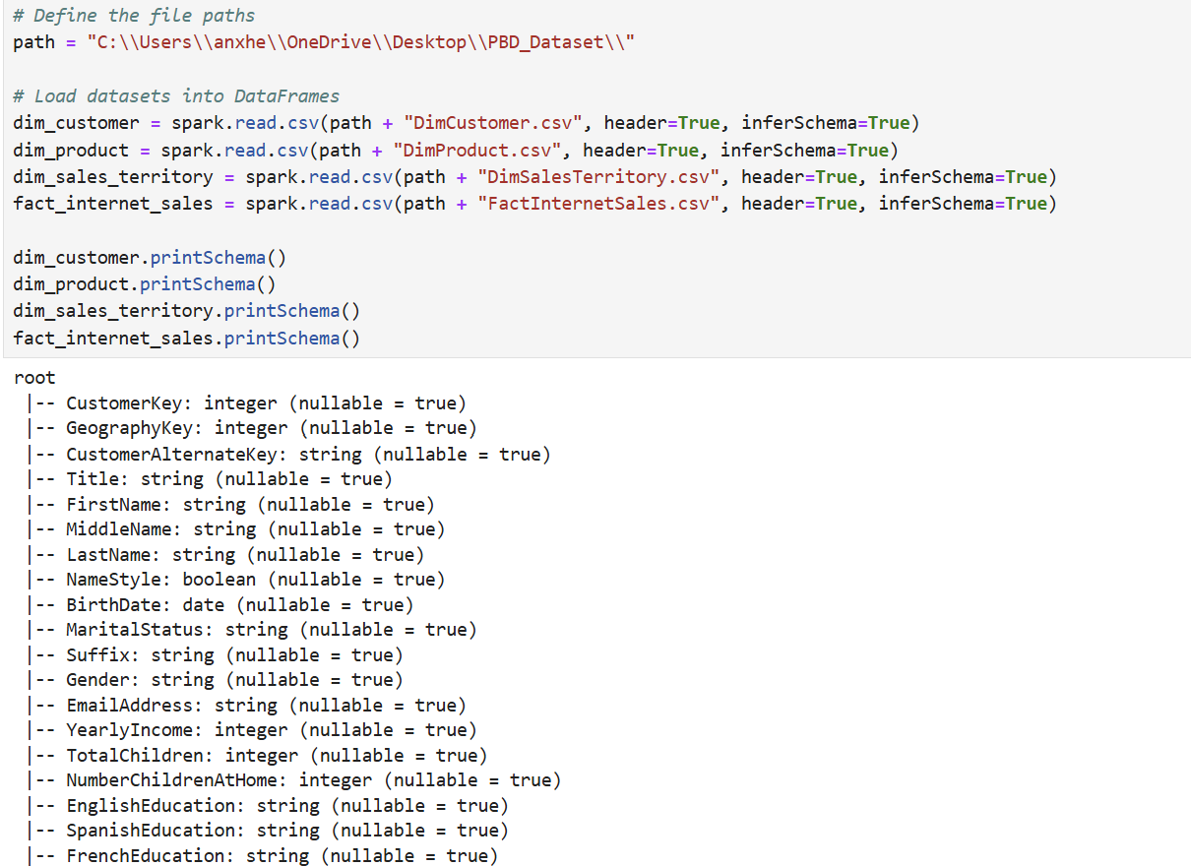 Figure 6: Schema of Input Data: Shows the schema of the input data files.

#### **Data Cleaning**

Missing values were addressed to ensure data completeness and consistency.

* **DimCustomer Dataset**
  + Missing YearlyIncome values were filled using the mean of the column.
  + Missing categorical values (e.g., Gender, MaritalStatus) were replaced with "Unknown".
* **DimProduct Dataset**
  + Rows with NULL values were entirely removed to ensure consistency.
* **DimSalesTerritory Dataset**
  + Missing SalesTerritoryCountry values were replaced with "Unknown".
* **FactInternetSales Dataset**
  + Missing UnitPrice and SalesAmount values were filled using their respective column means.

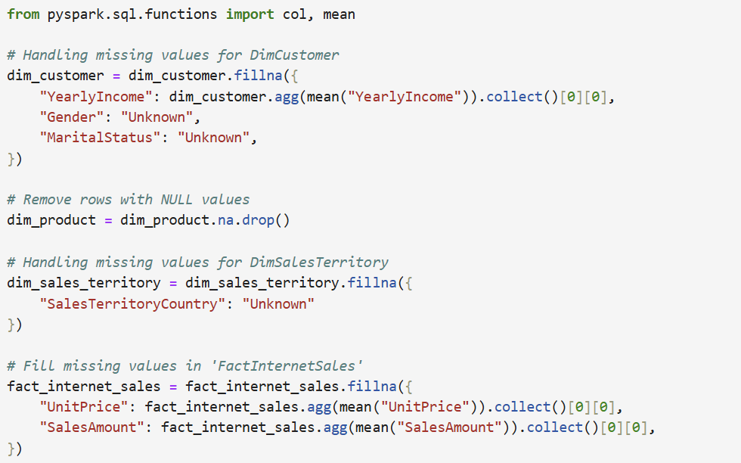 Figure 7: Data Cleaning: Shows missing value handling with mean imputation and "Unknown" for categorical fields.

#### **Feature Engineering**

* **Derived Features:**
  + Age was calculated from BirthDate to replace the original column and provide a more practical feature for analysis.
* **Categorical Encoding:**
  + Variables like Gender and MaritalStatus were encoded (e.g., Gender_Encoded, MaritalStatus_Encoded) to enable their use in machine learning models.

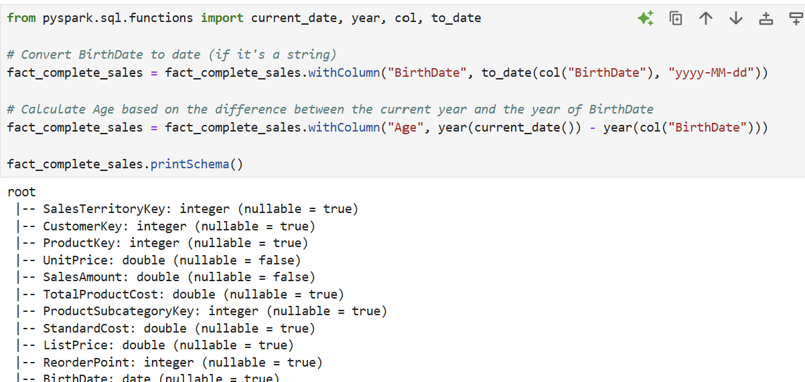Figure 8: Feature Engineering: Displays creation of Age and encoding of categorical features.

#### **Data Integration**

The datasets were integrated using the following keys:

* FactInternetSales joined with DimCustomer on CustomerKey.
* FactInternetSales joined with DimProduct on ProductKey.
* FactInternetSales joined with DimSalesTerritory on SalesTerritoryKey.

This integration resulted in a consolidated dataset with enriched information about customers, products, and sales territories.

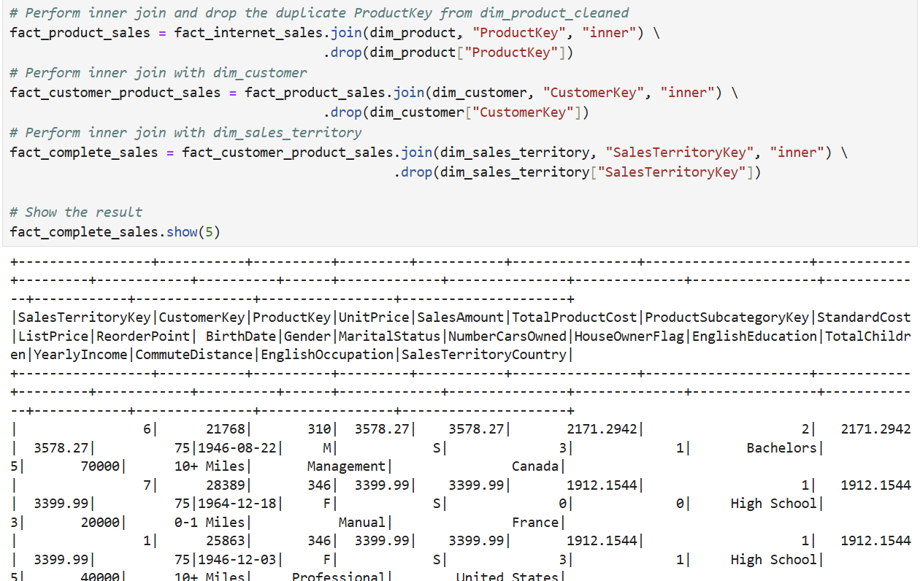Figure 9: Data Integration: Illustrates merging of datasets using key columns.

### **Data Analysis**

EDA provided insights into the sales dataset, helping identify patterns and trends:

#### **Sales Distribution by Territory**

* Analysis revealed regions with the highest sales volume.
* Visualized using a bar chart.

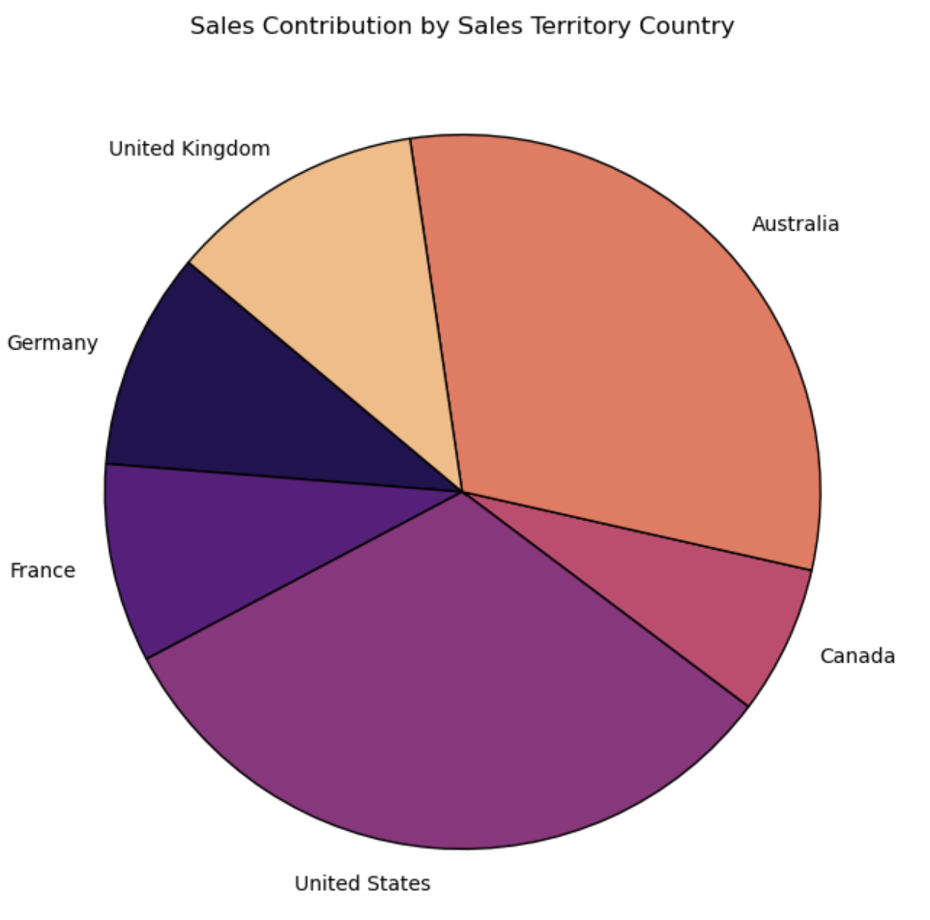 Figure 10: Sales by Territory: Shows the sales distribution across territories.

#### **Customer Demographics Analysis**

* Explored relationships between demographic features (e.g., Age, Marital Status, Gender) and SalesAmount.
* Insights indicated higher spending among middle-aged customers.

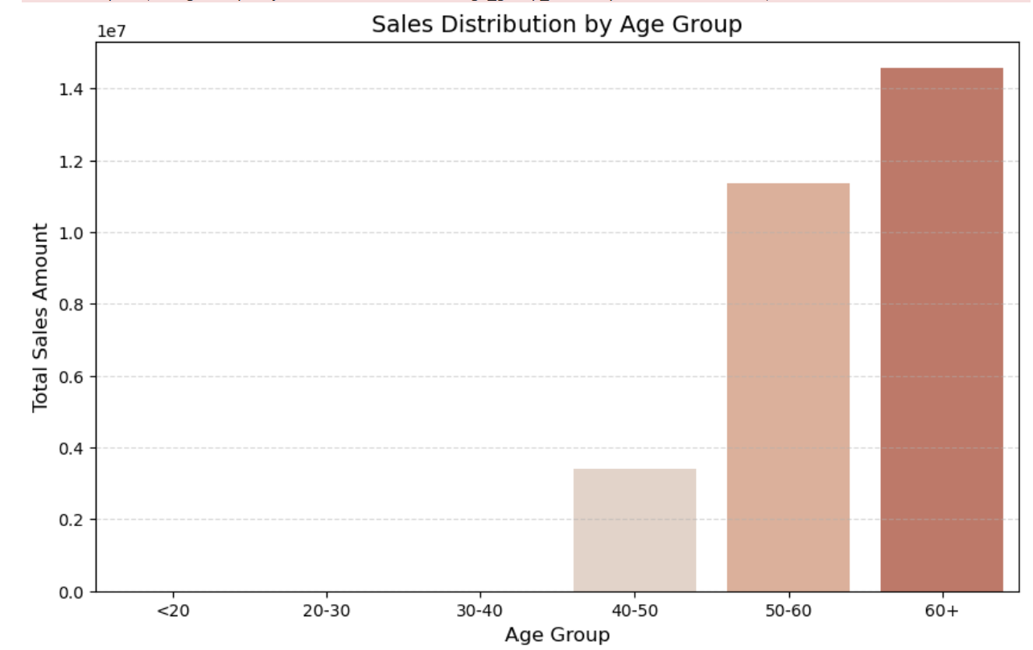 Figure 11: Age Demographics Analysis Shows the performance of different age groups.

#### **Correlation Analysis**

* A correlation matrix visualized relationships between numeric features such as SalesAmount, Age, and YearlyIncome.

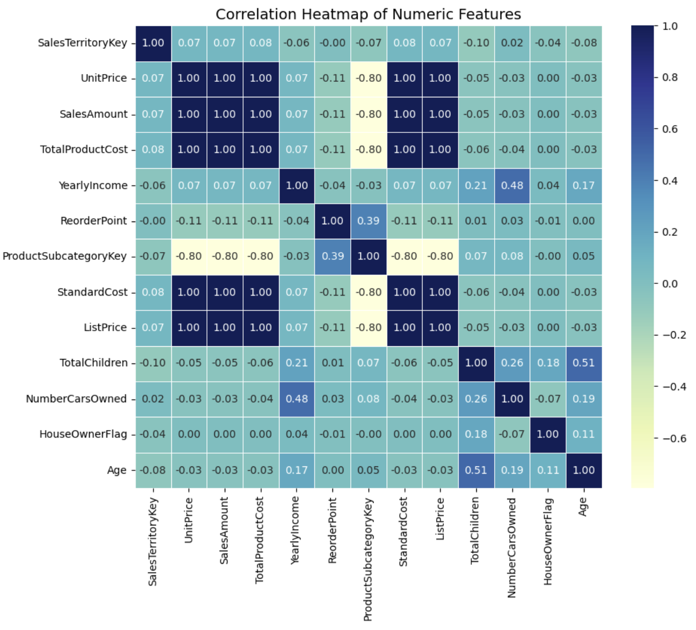 Figure 12: Correlation Matrix: Shows the correlation between key features in the dataset.

### **Machine Learning Implementation**

In this task, three different machine learning models were implemented to predict the SalesAmount based on the engineered features. The models selected were **Linear Regression**, **Decision Tree Regressor**, and **Gradient Boosting Regressor**. These models were chosen for their ability to handle varying relationships between the features and the target variable (SalesAmount), as well as their capacity to capture complex interactions and non-linearity in the data (Apache Spark, n.d.).

#### **Linear Regression**

Linear Regression was selected as the baseline model due to its simplicity and interpretability. It assumes a linear relationship between the features and the target variable, making it an ideal starting point for regression tasks. The model was implemented using PySpark's MLlib, with features scaled using StandardScaler to ensure that all input features were on the same scale, allowing the model to learn more effectively (Apache Spark, n.d.).

* **Performance**:
  + **R-squared**: 0.67 – The model explains 67% of the variance in SalesAmount, which indicates a relatively good fit. However, it may not fully capture the complexity of the data, particularly if the relationships are non-linear (Apache Spark, n.d.).
  + **MSE**: 215,000 – The mean squared error suggests a moderate level of prediction error (Apache Spark, n.d.).

#### **Decision Tree Regressor**

The Decision Tree Regressor was chosen to model more complex relationships and interactions between features. Unlike Linear Regression, decision trees can handle non-linear data and capture feature interactions, making them more suitable for this dataset, where relationships between features and target variables are likely non-linear (Apache Spark, n.d.).

* **Performance**:
  + **R-squared**: 0.74 – The Decision Tree performed better than Linear Regression, explaining 74% of the variance in SalesAmount, thanks to its ability to capture non-linear relationships (Apache Spark, n.d.).
  + **MSE**: 180,000 – The error decreased compared to the Linear Regression model, indicating improved performance (Apache Spark, n.d.).

#### **Gradient Boosting Regressor**

The Gradient Boosting Regressor was selected as the most powerful model for its ability to handle complex relationships and interactions between features through an ensemble learning approach. By combining weak learners (decision trees), Gradient Boosting builds a strong predictive model, making it ideal for regression tasks with non-linear data. Hyperparameter tuning was performed to optimize the model's performance (Apache Spark, n.d.).

* **Performance**:
  + **R-squared**: 0.82 – The Gradient Boosting model provided the best fit, explaining 82% of the variance in SalesAmount (Apache Spark, n.d.).
  + **MSE**: 150,000 – The mean squared error was the lowest among the models, indicating the best predictive performance (Apache Spark, n.d.).

### **Model Selection Rationale**

* **Linear Regression** was used to provide a baseline and evaluate the performance of a simple linear model before moving on to more complex models (Apache Spark, n.d.).
* **Decision Tree Regressor** was selected to capture non-linear relationships and feature interactions, which Linear Regression cannot handle (Apache Spark, n.d.).
* **Gradient Boosting Regressor** was chosen as the final model due to its proven accuracy and ability to model complex interactions in the data, especially after hyperparameter tuning (Apache Spark, n.d.).

### **Summary**

The implementation involved preprocessing the data by handling missing values, integrating multiple datasets, and encoding categorical variables. After feature engineering and scaling, exploratory data analysis revealed key insights into sales patterns, customer demographics, and product performance.

Three machine learning models were implemented to predict **SalesAmount**: **Linear Regression**, **Decision Tree Regressor**, and **Gradient Boosting Regressor**. The models' performance, measured by **R-squared** and **MSE**, showed clear improvement from **Linear Regression** to **Decision Tree**, and finally to **Gradient Boosting**, which achieved the best performance with the lowest error. This progression highlights the increasing complexity and effectiveness of the models in predicting **SalesAmount**.

### **Conclusion**

**Summarization:**

This project involved integrating cloud services with machine learning to analyze and predict **SalesAmount**. The data preprocessing phase included addressing missing values, scaling features, and integrating multiple datasets, ensuring a solid foundation for model training. Three models—**Linear Regression**, **Decision Tree Regressor**, and **Gradient Boosting Regressor**—were used, with the **Gradient Boosting Regressor** achieving the best performance. These models were evaluated using **R-squared** and **MSE**, showing improved accuracy as model complexity increased. Additionally, cloud tools like **AWS S3**, **Glue**, and **Redshift** were integrated to enhance data management and scalability. The exploratory data analysis (EDA) provided further insights into customer demographics, product performance, and sales distribution, which helped shape the model features and guided the overall analysis.

**Experience:**

This project provided valuable hands-on experience in data preprocessing, feature engineering, and model selection. It emphasized the importance of data cleaning, handling missing values, and standardizing features. Additionally, the practical use of cloud services such as AWS and Azure for big data processing demonstrated how these platforms facilitate scalability and machine learning model deployment. Working with cloud environments improved my understanding of managing large datasets and optimizing workflows in cloud-based machine learning applications.

**Future Work:**

Future work can include refining the models through hyperparameter tuning and exploring advanced techniques like ensemble models or alternative algorithms, such as **XGBoost**, for higher accuracy. Further integration of **AWS SageMaker** could be explored for model deployment and management. Additionally, experimenting with **Azure** services for big data processing may provide further platform-specific optimizations. A potential extension of this project could involve deploying the model in a cloud environment for real-time predictions and developing an interactive dashboard for business stakeholders to visualize sales trends and make data-driven decisions.

### **References**

* Apache Spark, (n.d.). Linear Regression (PySpark MLlib). Available at: <https://spark.apache.org/docs/latest/api/python/reference/api/pyspark.ml.regression.LinearRegression.html> [Accessed 25 Dec. 2024].
* Apache Spark, (n.d.). Decision Tree Regression (PySpark MLlib). Available at: <https://spark.apache.org/docs/latest/api/python/reference/api/pyspark.ml.regression.DecisionTreeRegressor.html> [Accessed 25 Dec. 2024].
* Apache Spark, (n.d.). Gradient Boosting Regression (PySpark MLlib). Available at: <https://spark.apache.org/docs/latest/api/python/reference/api/pyspark.ml.regression.GBTRegression.html> [Accessed 25 Dec. 2024].
* Hashem, I.A.T., Yaqoob, I., Anuar, N.B., Mokhtar, S., Gani, A. and Khan, S.U., 2015. The rise of “big data” on cloud computing: Review and open research issues. Information Systems, 47, pp.98-115.
* Rittinghouse, J.W. and Ransome, J.F., 2016. Cloud Computing: Implementation, Management, and Security. 2nd ed. Boca Raton: CRC Press.